European union bioeconomy data

Summary

The European Union has placed a plan of action to grow their bioeconomy and has already seen success. The action plan outlines the most impactful ways the continent can begin to rely on their bioeconomy. This includes facilitating the development of new sustainable biorefineries, developing alternatives to fossil fuel based materials that are biodegradable, recyclable, and bio-based. In 2015, it was estimated that 8% of jobs in the EU were attributed to the bioeconomy, and expects to create 1 million green jobs for rural and coastal areas by 2030. Under Horizon 2020, a funding program that allocated 80 billion euros to research and innovation in Europe, the bioeconomy received 3.85 billion euros. The government of the European Union has listed five main goals of the bioeconomy.
- Food and nutrition security
- Sustianabily manage natural resources
- Reduce dependence on renewable and unsustainable resources
- Limit and adapt to climate change
- Strengthen european competitiveness and create jobs
Similar to the UK, the EU has created strategies that are similar to policies but outline clear guidelines for plans of action. The EU strategies are the industrial circular economy strategy and the energy efficiency strategy. The European Union bioeconomy is defined by its major sectors which include agriculture, energy, forestry, textile production, fisheries, agro-manufacturing, wood manufacturing, paper manufacturing, and the plastics and chemicals industry. The EU Joint Research Centre published data on most major sector’s contribution to gross value added, employment, and revenue. Below are the tables from Brief on jobs and growth in the EU Bioeconomy 2012-2021

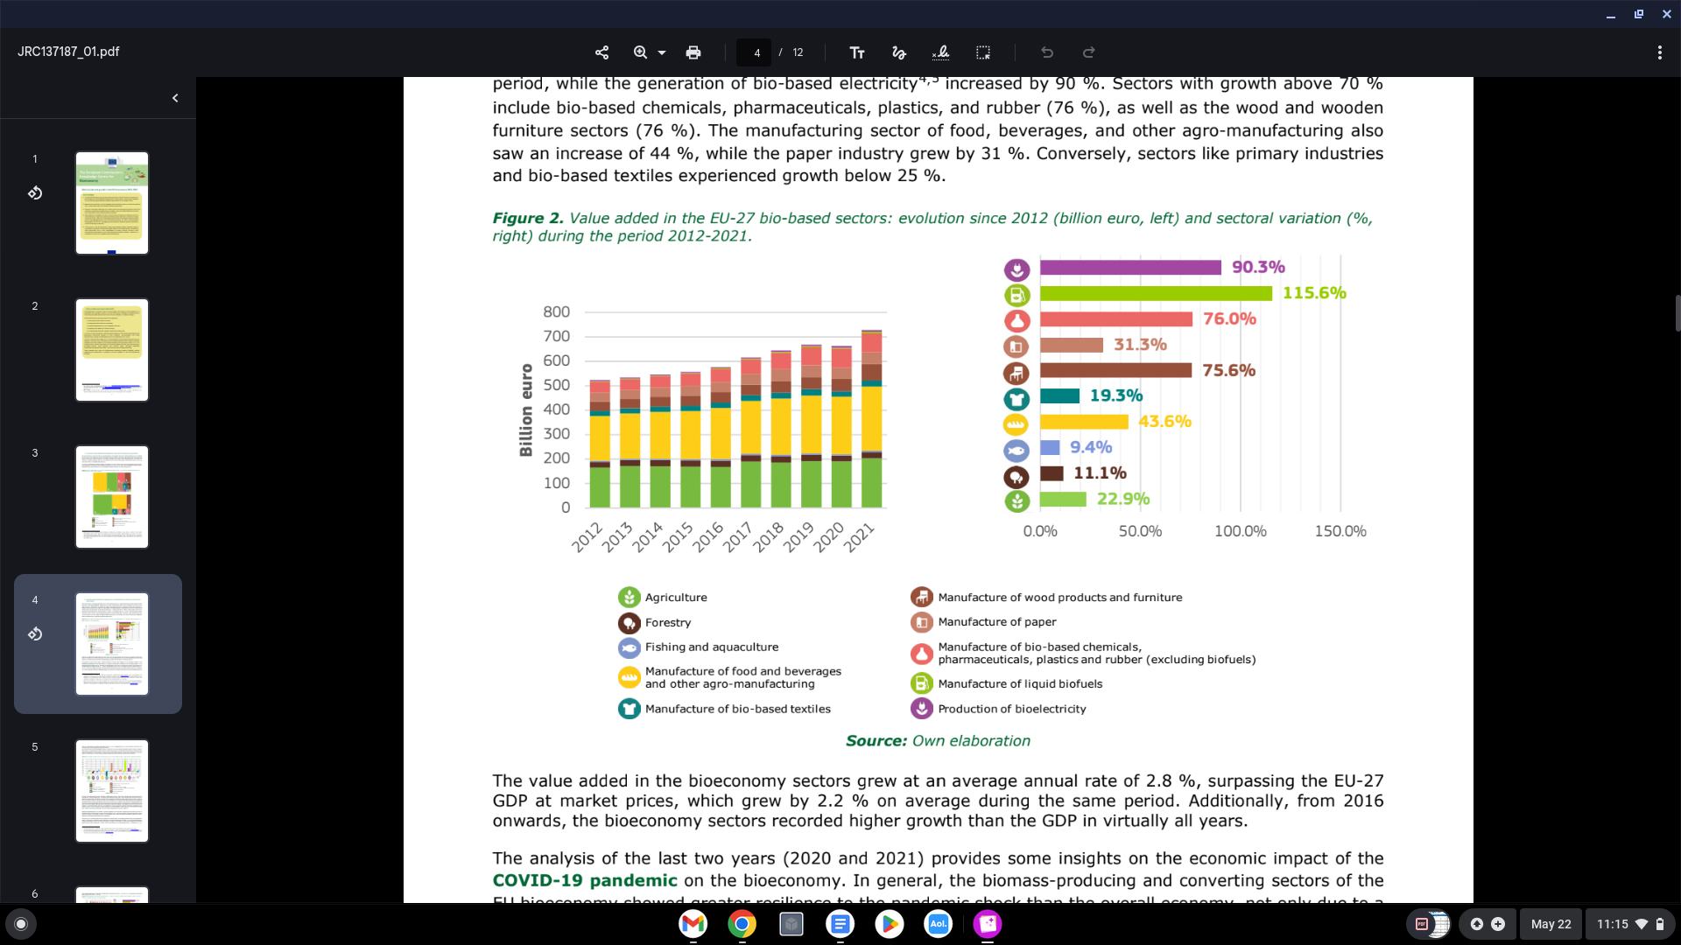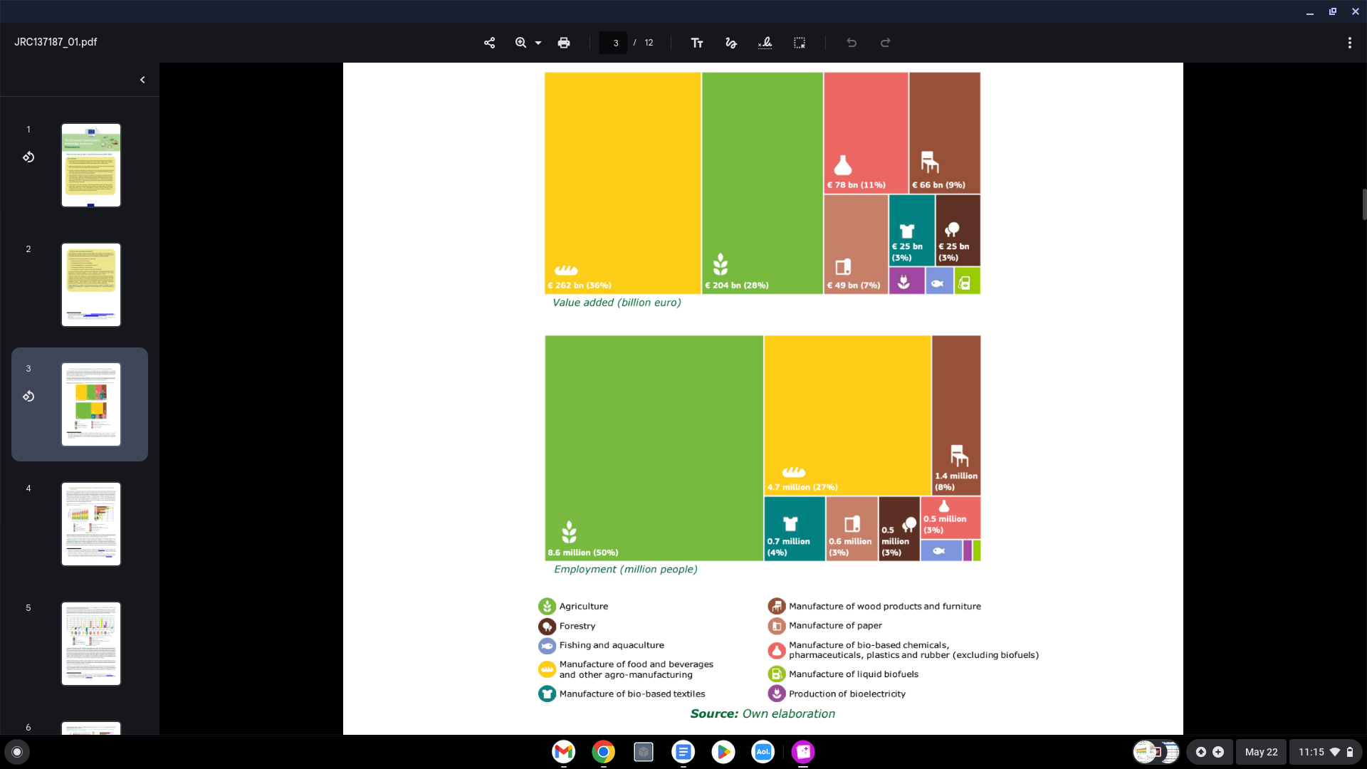

Table

European Union | Summary | Related Files
Incentives/goals | - Food and nutrition security  - Sustianabily manage natural resources  - Reduce dependence on renewable and unsustainable resources  - Limit and adapt to climate change  - Strengthen european competitiveness and create jobs | Bioeconomy Strategy for a Sustainable Europe
Policies/strategies | - Industrial circular economy strategy  - Chemical strategies for sustainability  - Sustainable financing  - Zero pollution action plan  - Farm to fork strategy  - European Climate Law  - Adaptation Strategy  - Forest Strategy | EU Bioeconomy Strategy Progress Report European Bioeconomy policy: stocktaking and future developments (pg. 16)
Jobs | - EU bioeconomy expected to create 1 million green jobs by 2030  - By 2015, 8% of jobs in the EU pertained to the bioeconomy  - Biorefineries  - Clean energy  - Employment is predicted to rise substantially by 2030 in water supply and waste management (63.2%0), construction (3.8%), electricity (17.2%), and basic metals and metal products (2.2%) | The green employment and skills transformation: insights from a European Green Deal skills forecast scenario
Revenue | - 728 billion EUR added by 2021 to European economy from bioeconomy  - Higher growth than the overall gdp recorded since 2016 | The European’s commission centre of knowledge of the bioeconomy

Sources

https://research-and-innovation.ec.europa.eu/document/download/bc992135-8261-4941-b941-5f5bdeb4b2a0_en?filename=new_bioeconomy_strategy_for_a_sustainable_europe.pdf

https://bpb-eu-w2.wpmucdn.com/blogs.reading.ac.uk/dist/a/171/files/2016/08/Evidencing-the-Bioeconomy.pdf

https://ec.europa.eu/eurostat/databrowser/explore/all/all_themes?lang=en&display=list&sort=category

https://www.cedefop.europa.eu/files/4206_en.pdf
https://eur-lex.europa.eu/legal-content/EN/TXT/PDF/?uri=CELEX:52022DC0283

https://publications.jrc.ec.europa.eu/repository/handle/JRC137187

